JOBSHEET I
BASIC PROGRAMMING



From:
AL AZHAR RIZQI RIFA’I FIRDAUS
Class:
1 I
Absence:
01
Major:
Information Technology
Study Program:
Informatic Engineering

  - Learning Objective
After finishing this practicum, students will be able to:
- Understand of conditional statements, loops, array, and function
- Implementation of using conditional statements, loops, array, and function in code program
  - Conditional Statements
The theory of this practicum is already explained in Basic Programming course. Therefore, in this practicum session we will do a quick review of your understanding by answering the following questions.
    - Practicum of Conditional Statements
Questions
- Create a program to calculate final score of students with these compositions. 20% of final score comes from assignment score, 35% from midterm score, and 45% from final exam. Each input score ranges from 0 – 100. Once the final score is determined, do the conversion as follows:
Score | Alphabets
80 < N ≤ 100 | A
73 < N ≤ 80 | B+
65 < N ≤ 73 | B
60 < N ≤ 65 | C+
50 < N ≤ 60 | C
39 < N ≤ 50 | D
N ≤ 39 | E

If the acquired alphabets are A, B+, B, C+, C then the student is passed. Otherwise, the student is failed.
- The program needs inputs for assignment score, midterm, final exam score
- The output will be the final score, its alphabet, and information whether they passed or failed

Example:
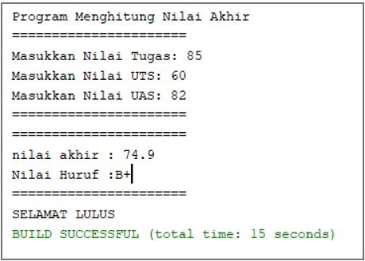
Code :
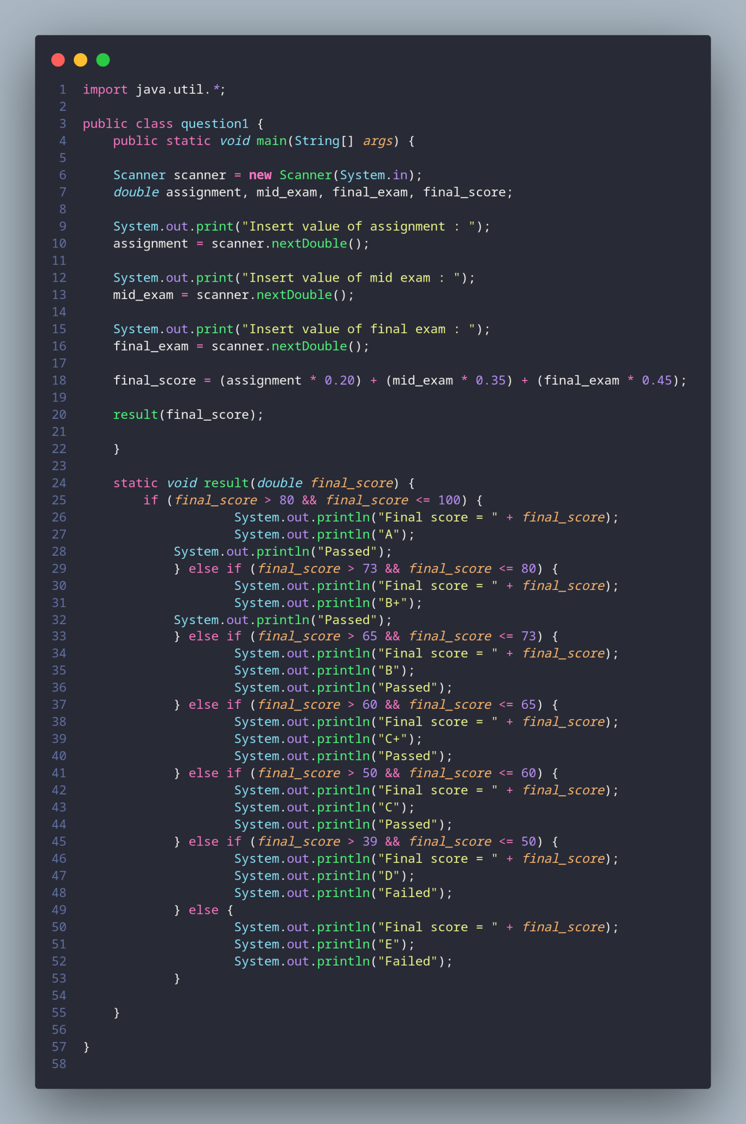
Result:
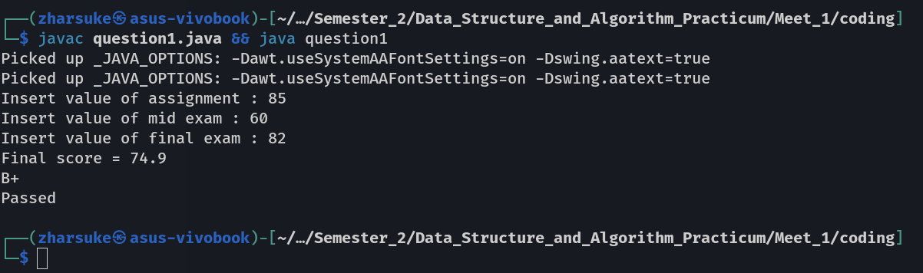
  - Loops
The theory of this practicum is already explained in Basic Programming course. Therefore, in this practicum session we will do a quick review of your understanding by answering the following questions.
    - Practicum of Loops
Question
- Create a program that can display the day from Monday to Sunday repetitively with days amount is n, the n will be the last 2 digits from your NIM.
*if n < 10, then add 10 (n+=10)
Example:
Input NIM: 2041720010, then n = 10
OUTPUT: Monday Tuesday Wednesday Thursday Friday Saturday Sunday Monday Tuesday Wednesday
2nd Example:
Input NIM: 2041720002, then n = 12
OUTPUT: Monday Tuesday Wednesday Thursday Friday Saturday Sunday Monday Tuesday Wednesday Thursday Friday

Example result:
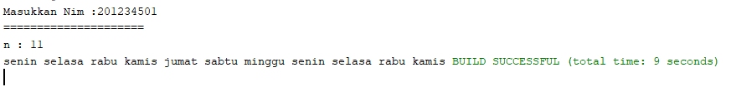
Code:
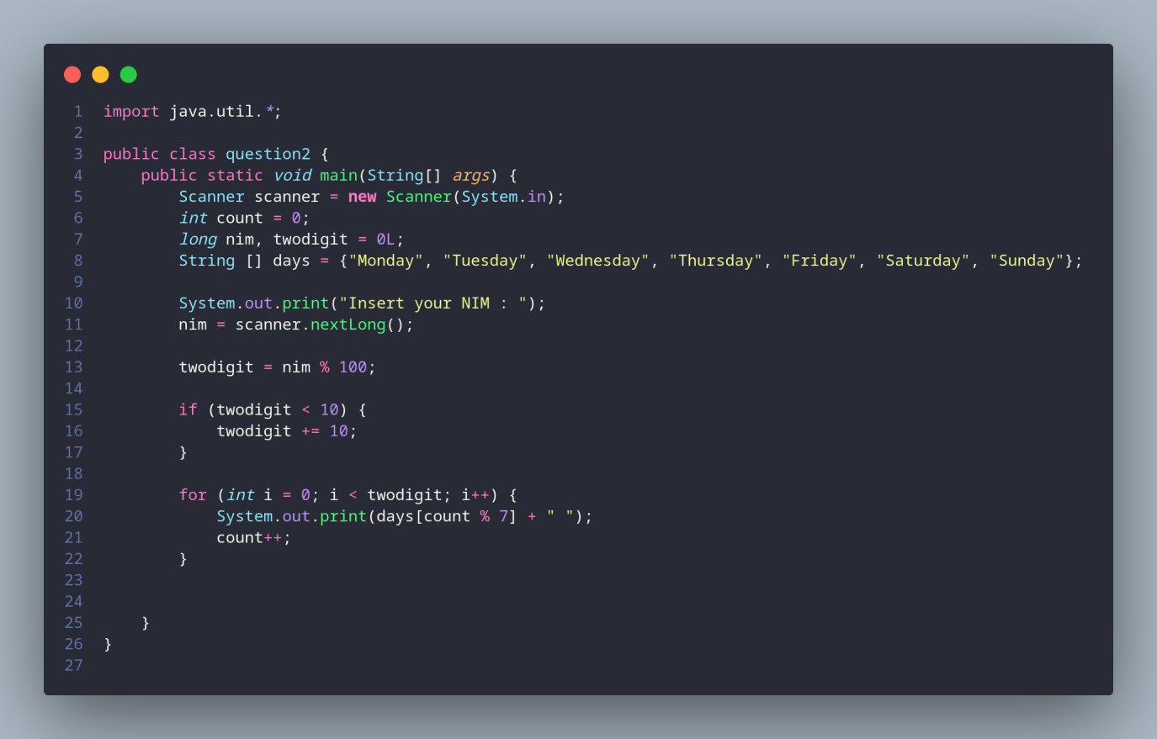
Result:
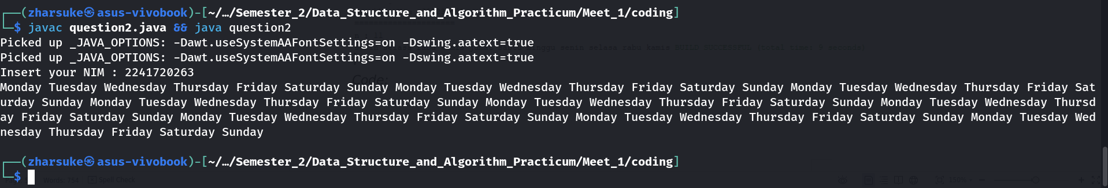

  - Array
The theory of this practicum is already explained in Basic Programming course. Therefore, in this practicum session we will do a quick review of your understanding by answering the following questions.
    - Practicum of Array
Question
- RoyalGarden is a flower shop that has many branches. Every day, the sold flowers and its stock has recorded as follows
 | Aglaonema | Taro | Alocasia | Rose
RoyalGarden 1 | 10 | 5 | 15 | 7
RoyalGarden 2 | 6 | 11 | 9 | 12
RoyalGarden 3 | 2 | 10 | 10 | 5
RoyalGarden 4 | 5 | 7 | 12 | 9
The price for each Aglaonema is 75.000, Taro is 50.000, Alocasia is 60.000, and Rose is 10.000. Please help RoyalGarden to create a program that can calculate:
- Stock for each flower through all branches
- If there is an additional information about a stock has decreased since the flowers are wither or dead on RoyalGarden 1 branch. Those dead flowers are 1 Aglaonema, 2 Taros, and 5 Roses. Please calculate the income of RoyalGarden 1 if all flowers are sold out.
Code:
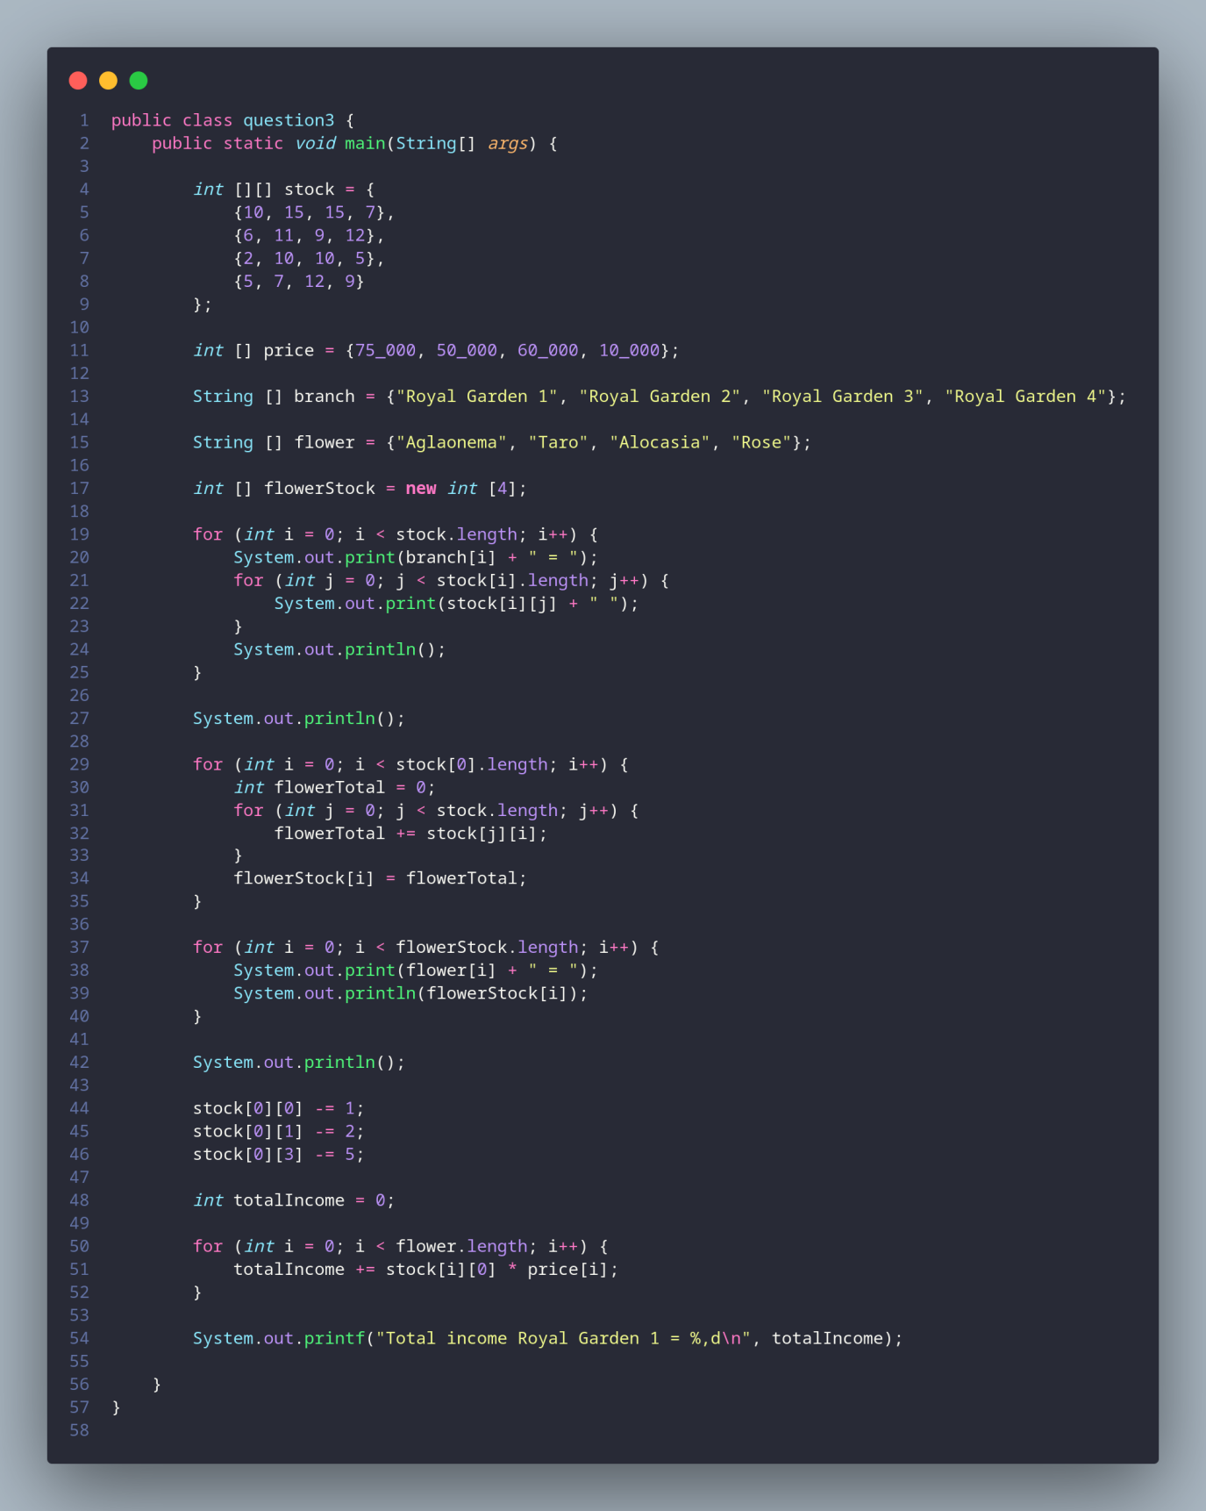
Result:
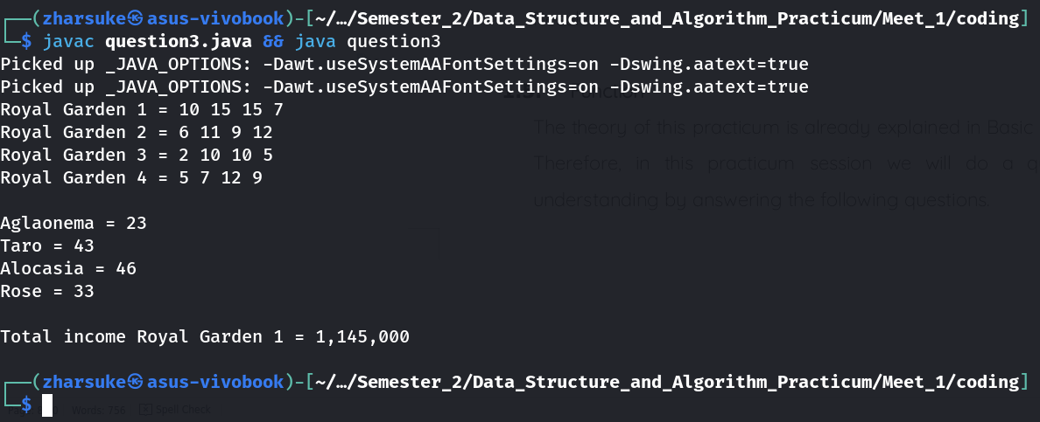
  - Function
The theory of this practicum is already explained in Basic Programming course. Therefore, in this practicum session we will do a quick review of your understanding by answering the following questions.
    - Practicum of Function
Question
- Create 2 functions for:
- Display Fibonacci row using loop
Code:
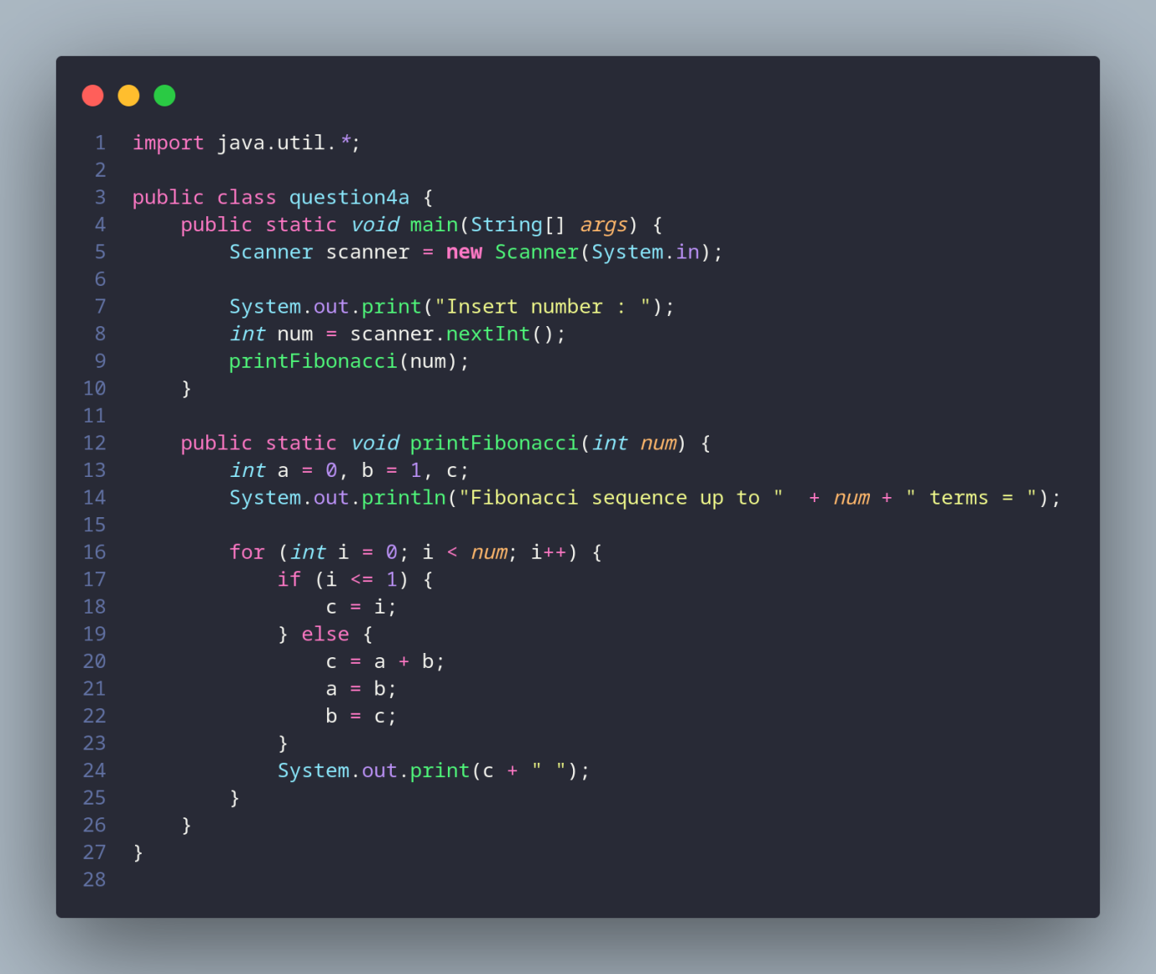
Result:
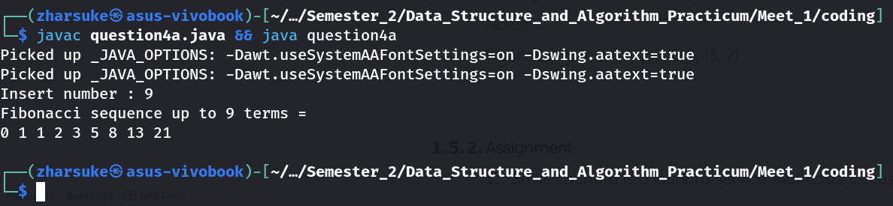
- Display Fibonacci row using recursive function
Notes:
Fibonacci row: 0, 1, 1, 2, 3, 5, 8, 13, 21
Code:
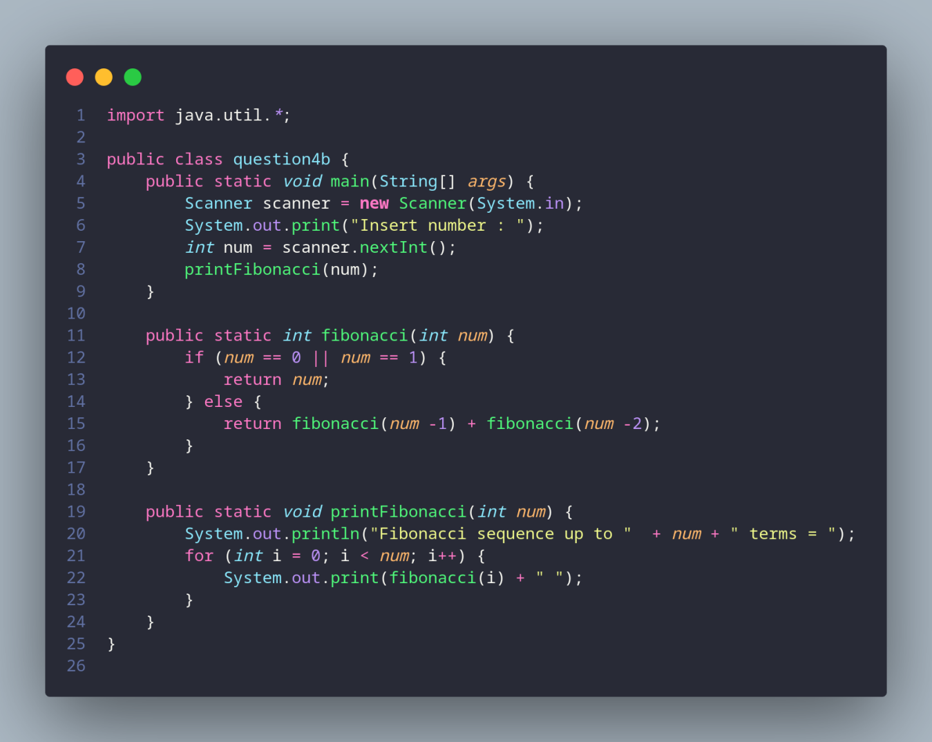
Result:
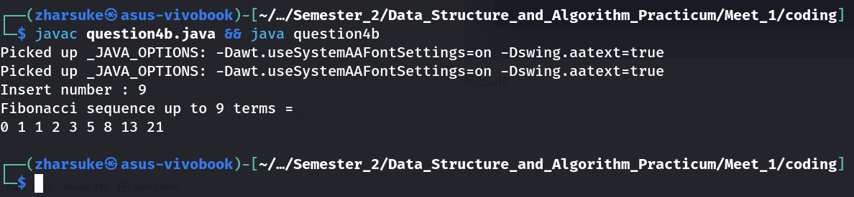

    - Assignment
- Smile Laundry is a laundry service that costs its customer as follows:
- Cost for each 1kg clothes is Rp 4.500
- If the customer does laundry more than 10kg clothes, they will get 5% discount
Today, the laundry has 4 customers, those are Ani, Budi, Bina, and Cita. Ani brought 4kg clothes, Budi brought 15kg clothes, Bina brought 6kg, and Cita brought 11kg. Create a program to calculate the income of Smile Laundry at that day.
Code:
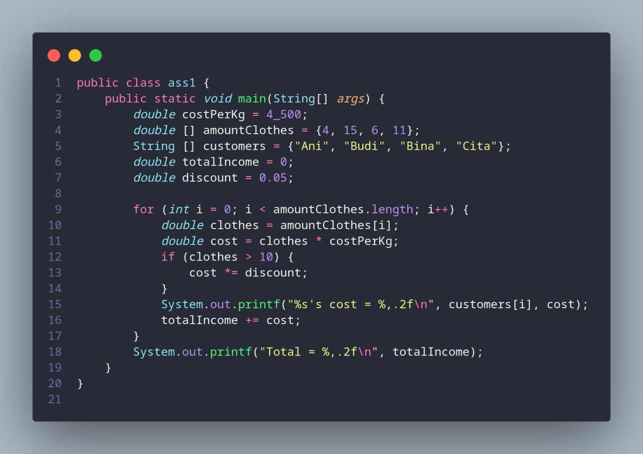
Result:
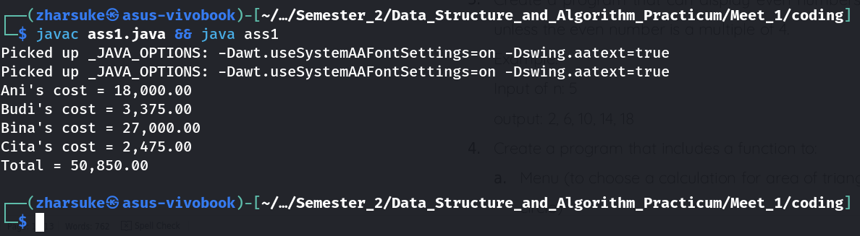
- Somebody saves 1 million rupiahs in a bank. With its interest is 2% for each month, then in what month does the customer balance reach 1.5 million? Create a program for this case study.
Code:
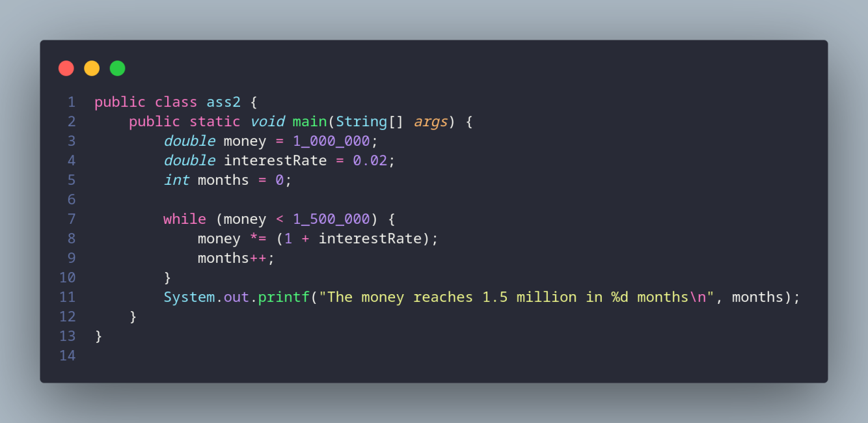
Result:
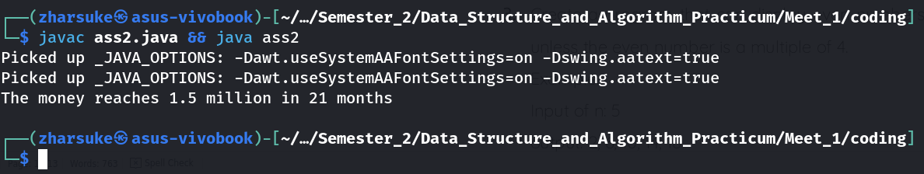
- Create a program that can display even numbers from 2 until nth row, unless the even number is a multiple of 4.
Example:
Input of n: 5
output: 2, 6, 10, 14, 18
Code:
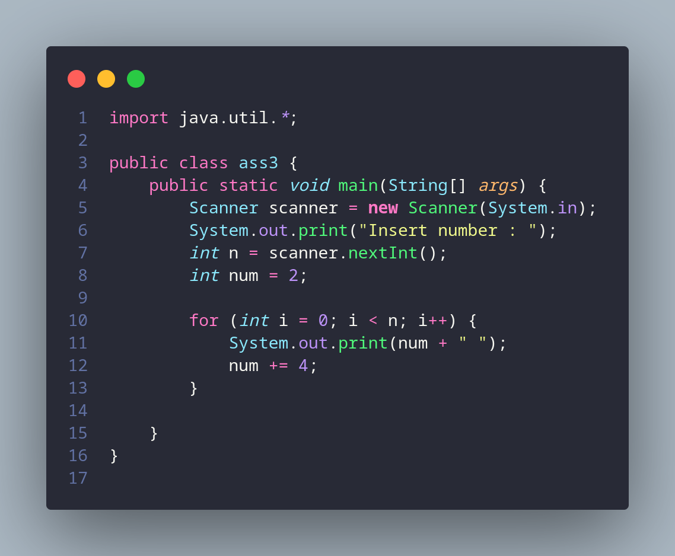
Result:
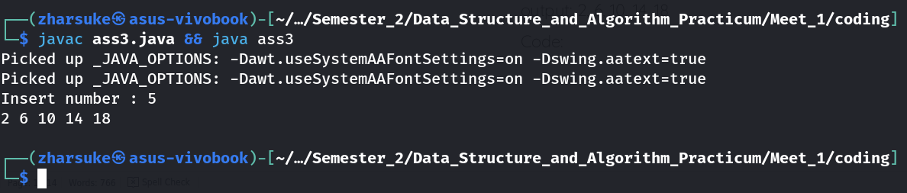
- Create a program that includes a function to:
- Menu (to choose a calculation for area of triangle / rectangle / circle)
Code:
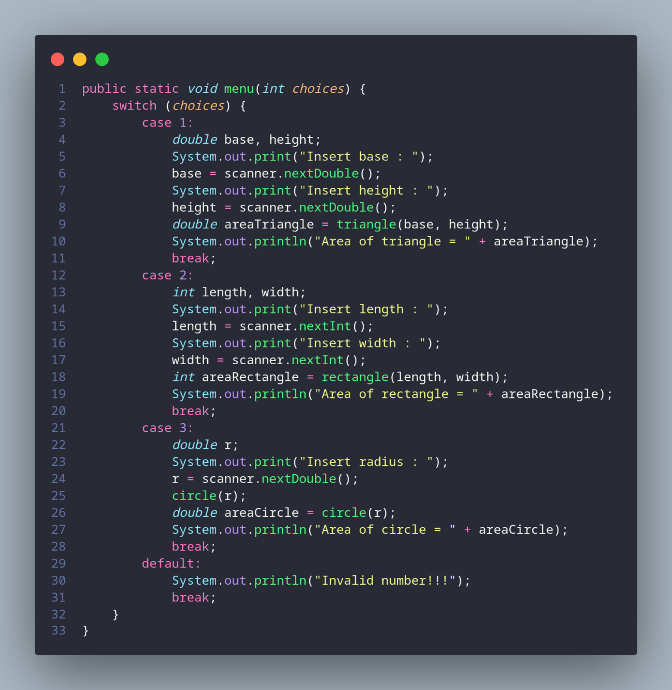
- Calculate area of triangle
Code:
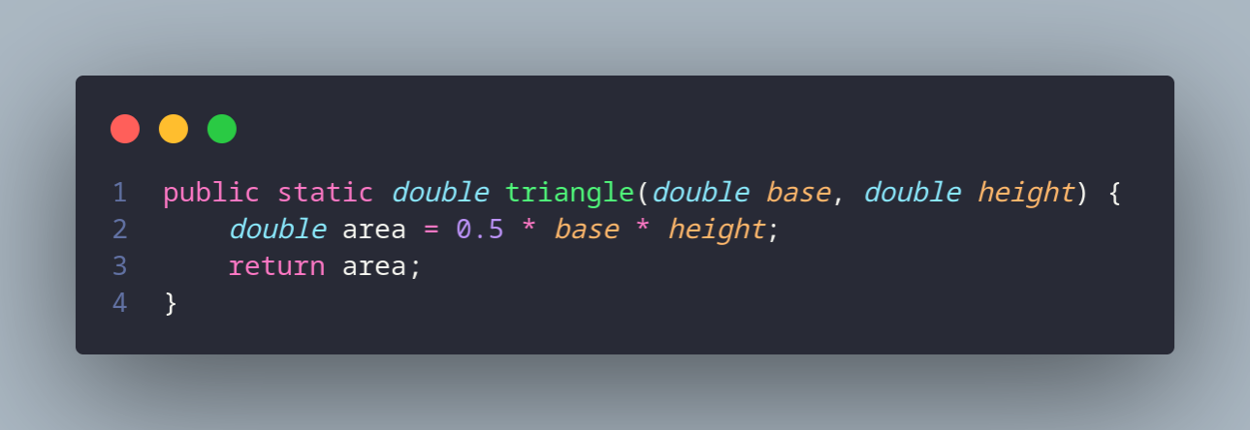
- Calculate area of rectangle
Code:
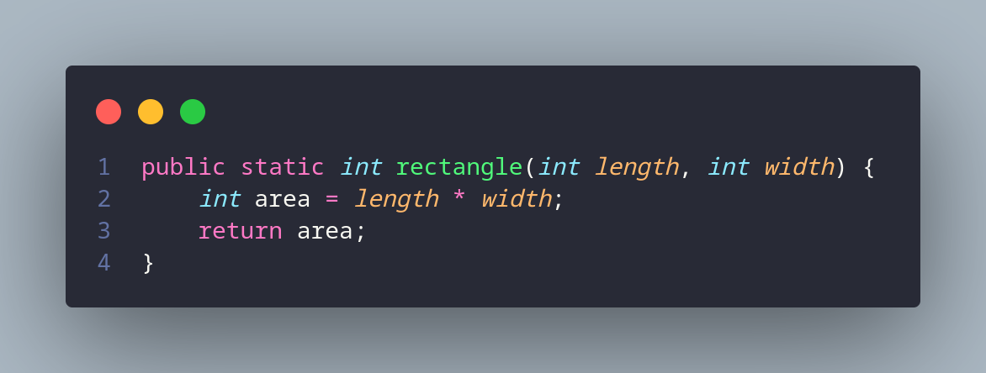
- Calculate area of circle
code:
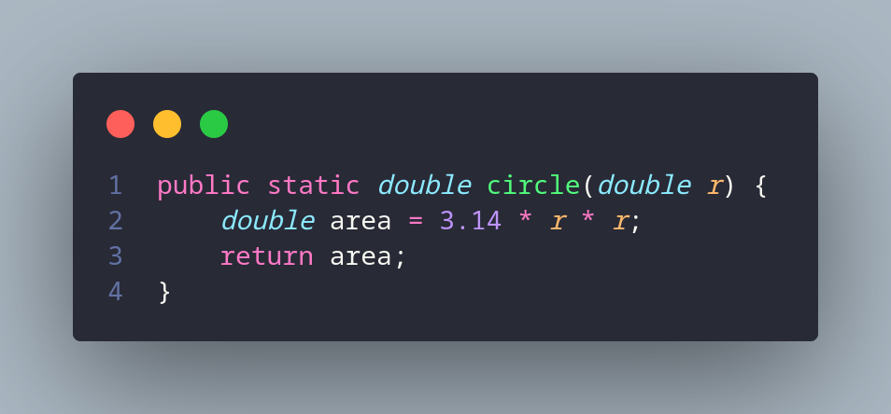
Result:
